Dear Taoiseach,
Welcome to Newbridge!
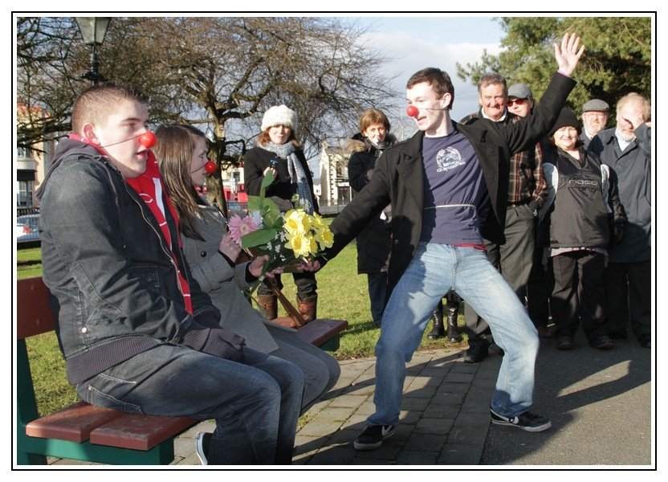
We are a voluntary collective of young people who make theatre and generate happiness.
We believe we are lucky and privileged to live in this part of north-western Europe. But we are nonetheless aware of the many challenges facing our families, our communities, our nation, and our world.
If we had to suggest three areas that our government could help us with, they would be:
(1) Reforming the CAO system so that the pressure of gaining points is not determining the way we are taught in our secondary schools. We need to release schools from this end-goal so that creative, engaged learning can take place in an environment that is not driven by the points system nor by the pressure of economics.
(2) Invest more in public transport than in car-focused infrastructure. We like trains. They should be cheaper, there should be more of them, and there should be a range of routes to use. We, and the elderly, are the prime users of busses and trains. Let’s take example from Europe and make train travel cheaper and ubiquitous.
(3) Help us establish and preserve town-centre spaces for public use. We have enough spaces for retail and residential use in our towns. We need civic buildings for culture, community, gatherings, and learning. These spaces are disappearing into the maw of economic development.
Thank you for visiting us!
All at Crooked House & Kildare Youth Theatre.
www.kildareyouththeatre.com

